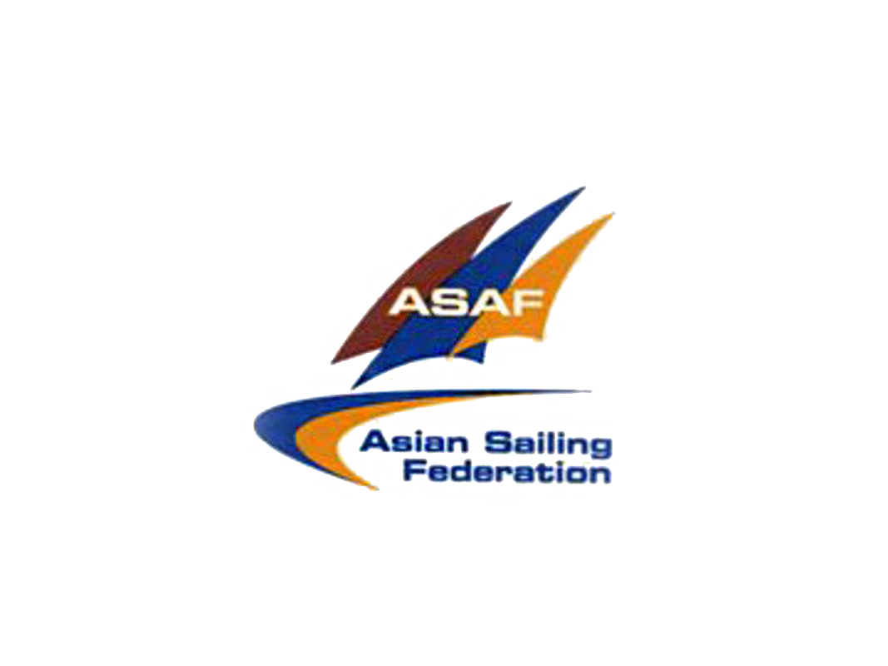

ASAF Keelboat Cup 2018 ENTRY FORM and DECLARATION

Eligible boats may enter the event by submitting the Entry Form, Crew list, Team Profile, Crew experience form (of
the skipper & at least 3 major crew members), a copy of skipper’s Certificate of Competency (i.e. yacht master
certificate, etc), together with the Entry Fee, Crew Fee and deposit to the Regatta Office on or before
1st Sep 2018

Liaison: Yuna Email: yuna@chncup.com tel. 86 755 88353518 ext 615 fax. 86 755 88323928

I wish to enter the ASAF Keelboat Cup 2018

I have read, and understood, the respective Notice of Race. I agree to be bound by the Rules as defined therein and in the ASAF Keelboat Cup 2018 Sailing Instructions.I shall notify the Race Committee immediately if any alteration is made to my boat which is likely to affect the rating (such as to sail plan, mast, ballast, trim, engine, propeller or hull measurement). The boat shall be made available for inspection as required.

I understand that yacht racing can be dangerous and that the ASAF Keelboat Cup 2018 Organizing Committee is not responsible for any loss of life or injury to members of my crew or other parties, or for the loss of, or damage to my vessel. I have read and understand RRS Fundamental Rule 4 – Decision to Race. Before the start of the race, I will ensure that all crew members are aware of the undertaking in this Declaration and of the importance of effecting appropriate personal insurance.

I understand and undertake to fulfil the Person in Charge's Responsibility as set out in Offshore Special Regulation 1.02. Before racing I shall affect adequate and suitable insurance and shall produce evidence thereof to the Race Committee upon demand.

I understand and agree that the information I give to the race organisers will be maintained on computer for the purposes of race administration.

Team Name |  | Country/region to represent |  | Affiliated Association/Club

Skipper |  | Mobile |  | Email |  | Fax
Liaison |  | Mobile |  | Email |  | Fax
Signature(Owner/Skipper/Liaison) |  |  |  |  |  | Date：

- FEES
Entry Fee RMB3,000 (HK$3,700 / US$475/EUR385)
Crew Fee: Each crew member,Skipper is free RMB 600 (HK$ 750 / US$ 95/EUR 75)

- PAYMENT METHOD
Please pay the entry fees to Shenzhen regatta office on or before 1st Sep 2018. Crew fee is also payable by cash
upon registration.
□ Bank Remittance
Name of beneficiary：CHINA CUP INTERNATIONAL REGATTA MANAGEMENT CO LTD
Name of bank：Bank of China (Hong Kong) Limited, Central District Branch
Address of bank：2A Des Voeux Road Central, Hong Kong
Account No.：01234910058610 (HKD); 01234992043218 (USD, EUR)
Swift Code：BKCHHKHH(8 digits) BKCHHKHHXXX(11 digits)

Please be reminded that the bank handling charges shall be at your cost.
A copy of bank note should be sent to Shenzhen Regatta Office

Team Profile

Team established year：
Pleae write your team's brief introduction here for Team Profile brochure and media promotion

Skipper & Major Crew ‘s Sailing Experiences
Name | Title | Races participated  (year, name & results) | Personal Honours, achievements  or credentials
 | Skipper
 | Crew
 | Crew
 | Crew

NB：Please provide the skipper and at least 3 major crew’s information factually for race committee’s approval and decide if the crew is eligible to enter the regatta.

